- To multiply your age by 2 and display it. For example, if your age is 16, so 16 * 2 = 32.
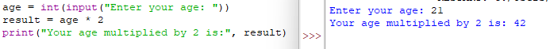
By writing this program, I learned how Python handles variables. In first step I used ‘int’ for age because age is a numeric value. As well, I used a function input(…) for the program to be universal.
b. Display the name of the city, country, and continent you are living in.
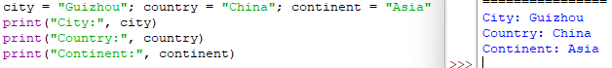
By writing this program, I learned how Python works with text. I used the string value type for city, country and continent.
c. To display the examination schedule (i.e., the starting and the ending day) of this term.
By writing this program, I learned that dates need to be used as the string value type. Dates cannot be defined as an integers or a float, because dates are a mix of numbers and symbols.
d. Display the temperature of your country on the day the assignment is attempted by you .
By writing this program, I learned how to use formulas for calculating different values, how maths works in code. I used the float type because temperature input need to accept decimals.

